**Software Test Report**

**Student Personal Finance Manager**

**Ishan Chakrabarti**

**21BCE0669**

|  |  |  |  |  |  |
| --- | --- | --- | --- | --- | --- |
| **Test Case ID** | **Test Objective** | **Test Data** | **Expected Results** | **Actual Results** | **Test Pass/Fail** |
| **1** | **Adding an expense to the table** | **Click on edit button and enter financial data (Rent,11-04-24, 15000 and Type (-))** | **Expense data is added to the Table**  **and balance is updated to 85000** | **Expense data is added to the Table and balance is updated to 85000** | **Pass** |
| **2** | **Editing an expense** | **Click on edit button and enter financial new data (Amount is set to 14000)** | **Table reflects updated data and balance is updated to 86000** | **Amount has properly been updated to 14000, however, the balance displayed is erroneous (71000 instead of 86000)** | **Fail** |
| **3** | **Deleting an expense** | **Click on delete button** | **Expense row is deleted from the Table** | **Expense row is deleted from the Table** | **Pass** |
| **4** | **Adding income to the table** | **Click on edit button and enter financial data (Salary, 01-04-2024, 125000 and Type (+))** | **Income data is added to the Table and balance is updated to 225000** | **Income data is added to the Table and balance is updated to 225000** | **Pass** |
| **5** | **Editing income** | **Click on edit button and enter new financial data (amount is 115000)** | **Table reflects updated data**  **and balance is updated to 215000** | **Amount has properly been updated, however, the balance displayed is erroneous (340000 instead of 215000)** | **Fail** |
| **6** | **Deleting income** | **Click on delete button** | **Income row is deleted from the Table** | **Income row is deleted from the Table** | **Pass** |
| **7** | **Downloading Expense/Earning Report** | **Click on Download Report Button and enter a date range (01-04-2024 to 30-04-2024)** | **A Text Report of financial data is downloaded** | **A Text Report of financial data is downloaded** | **Pass** |
| **8** | **Adding a reminder for a past date** | **Any past date (03-04-2024)** | **Reminder is added to the Table and page alerts user** | **Reminder is added to the Table and page alerts user** | **Pass** |
| **9** | **Adding a reminder for the current date** | **Present date (14-04-2024)** | **Reminder is added to the Table and page alerts user** | **Reminder is added to the Table and page alerts user** | **Pass** |
| **10** | **Adding a reminder for a future date** | **Any future date (24-04-2024)** | **Reminder is added to the Table** | **Reminder is added to the Table** | **Pass** |
| **11** | **Editing a reminder** | **Any date apart from the one in the input field (Rent date has been changed from 03-04-2024 to 18-04-2024)** | **Table reflects updated reminder** | **Table reflects updated reminder** | **Pass** |
| **12** | **Deleting a reminder** | **Click on Delete Button** | **Reminder row is deleted from the Table** | **Reminder row is deleted from the Table** | **Pass** |
| **13** | **Navigating to Finance Page** | **Click on Finance in Navigation Menu** | **Finance Page is opened** | **Finance Page is opened** | **Pass** |
| **14** | **Navigating to Reminder Page** | **Click on Reminder in Navigation Menu** | **Reminder Page is opened** | **Reminder Page is opened** | **Pass** |
| **15** | **Logout Button** | **Click on Logout Button** | **Application Window is closed** | **Application Window is closed** | **Pass** |

**Test Case – 1: Adding an expense to the table:**

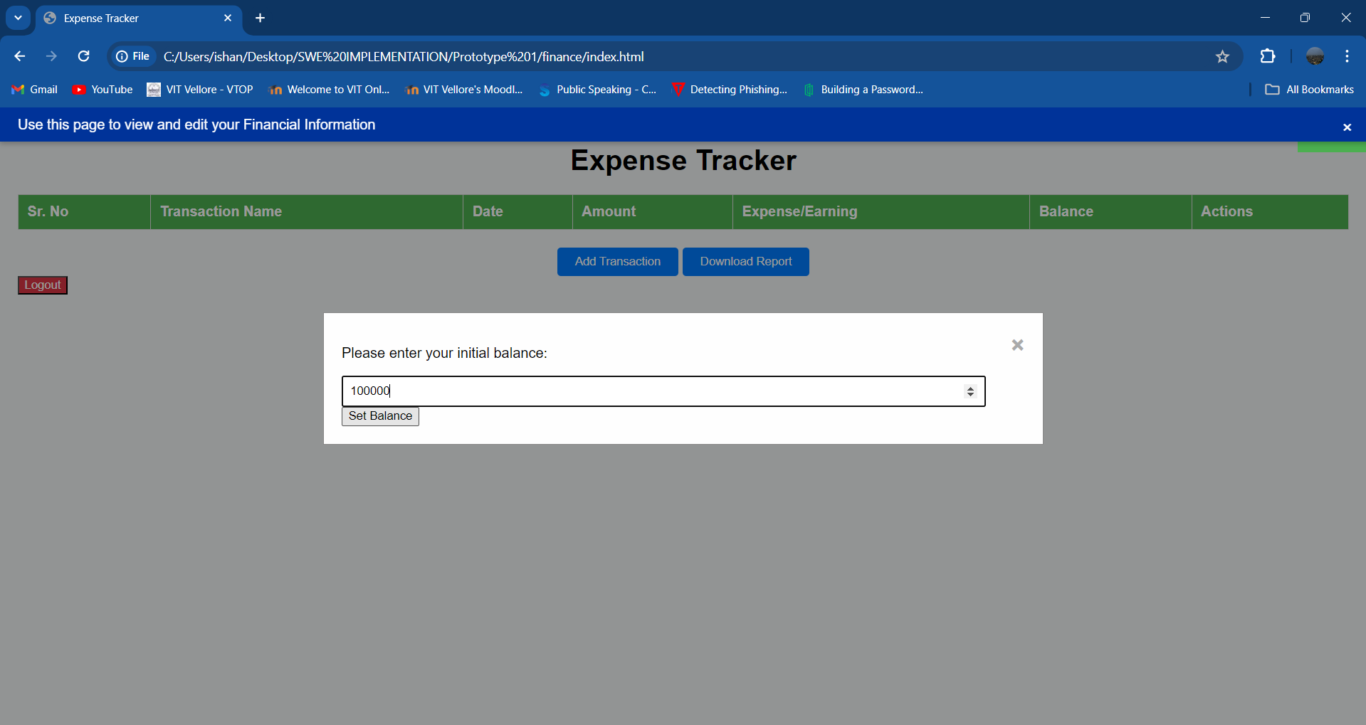

**Initial process for Finance module involves setting an initial balance.**

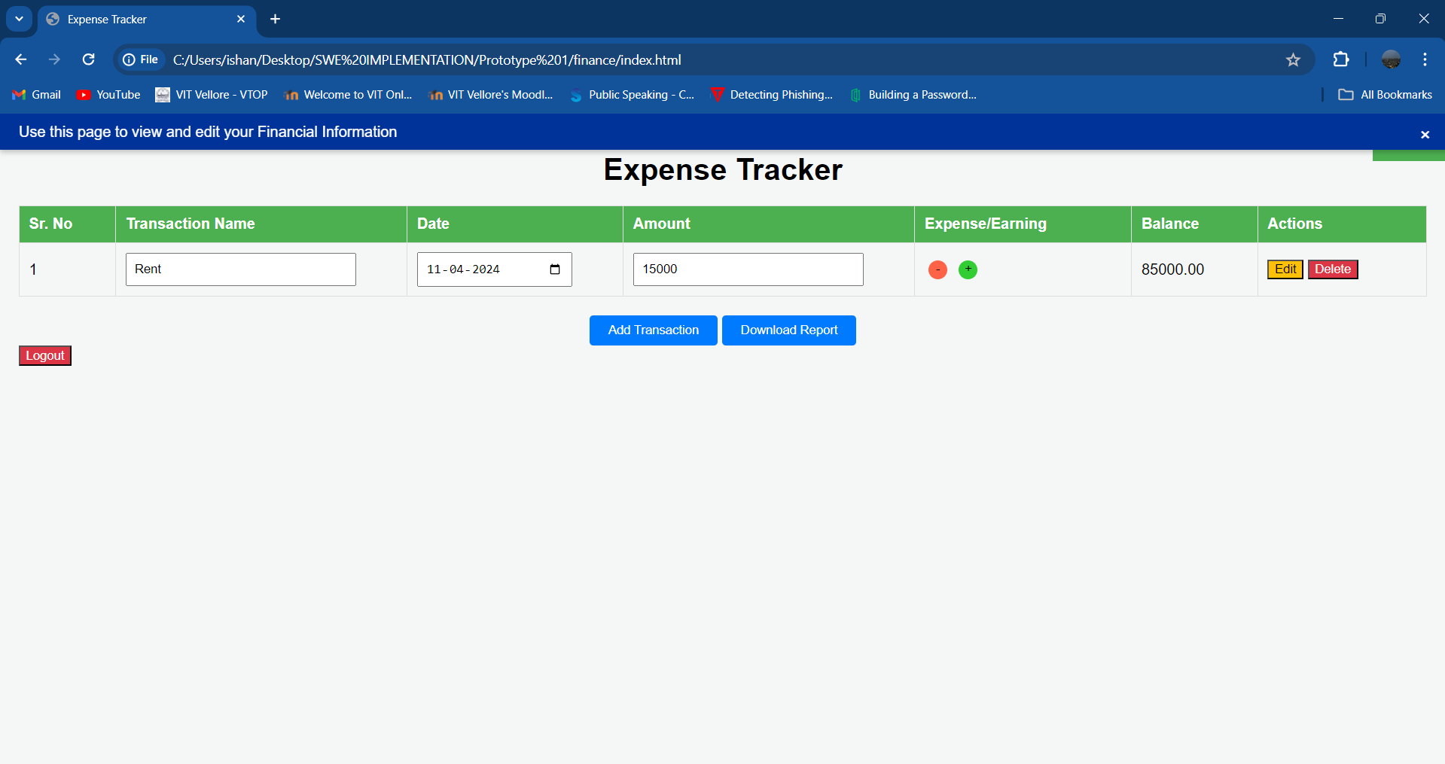

**Since the rent is counted as an expense, the red ‘-‘ button is selected.**

**Test Case – 2: Editing an expense:**

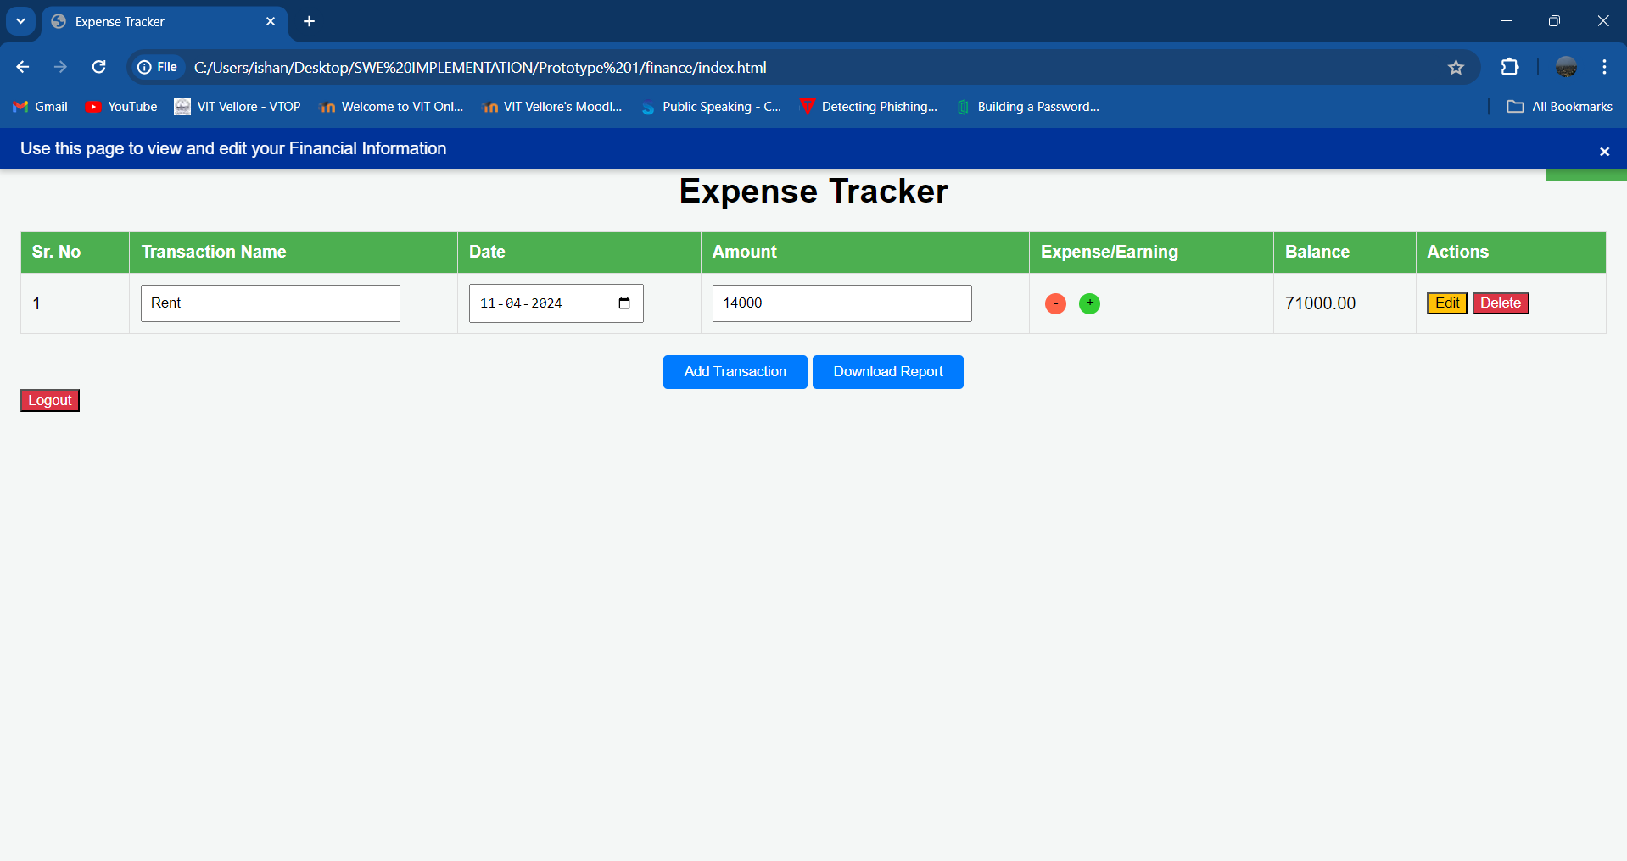

**Rent has been reduced to 14000, however, the page has updated the balance to 71000 instead of 86000, as the edit has been applied to the new balance of 85000 and not the old balance of 100000.**

**Test Case – 3: Deleting an expense:**

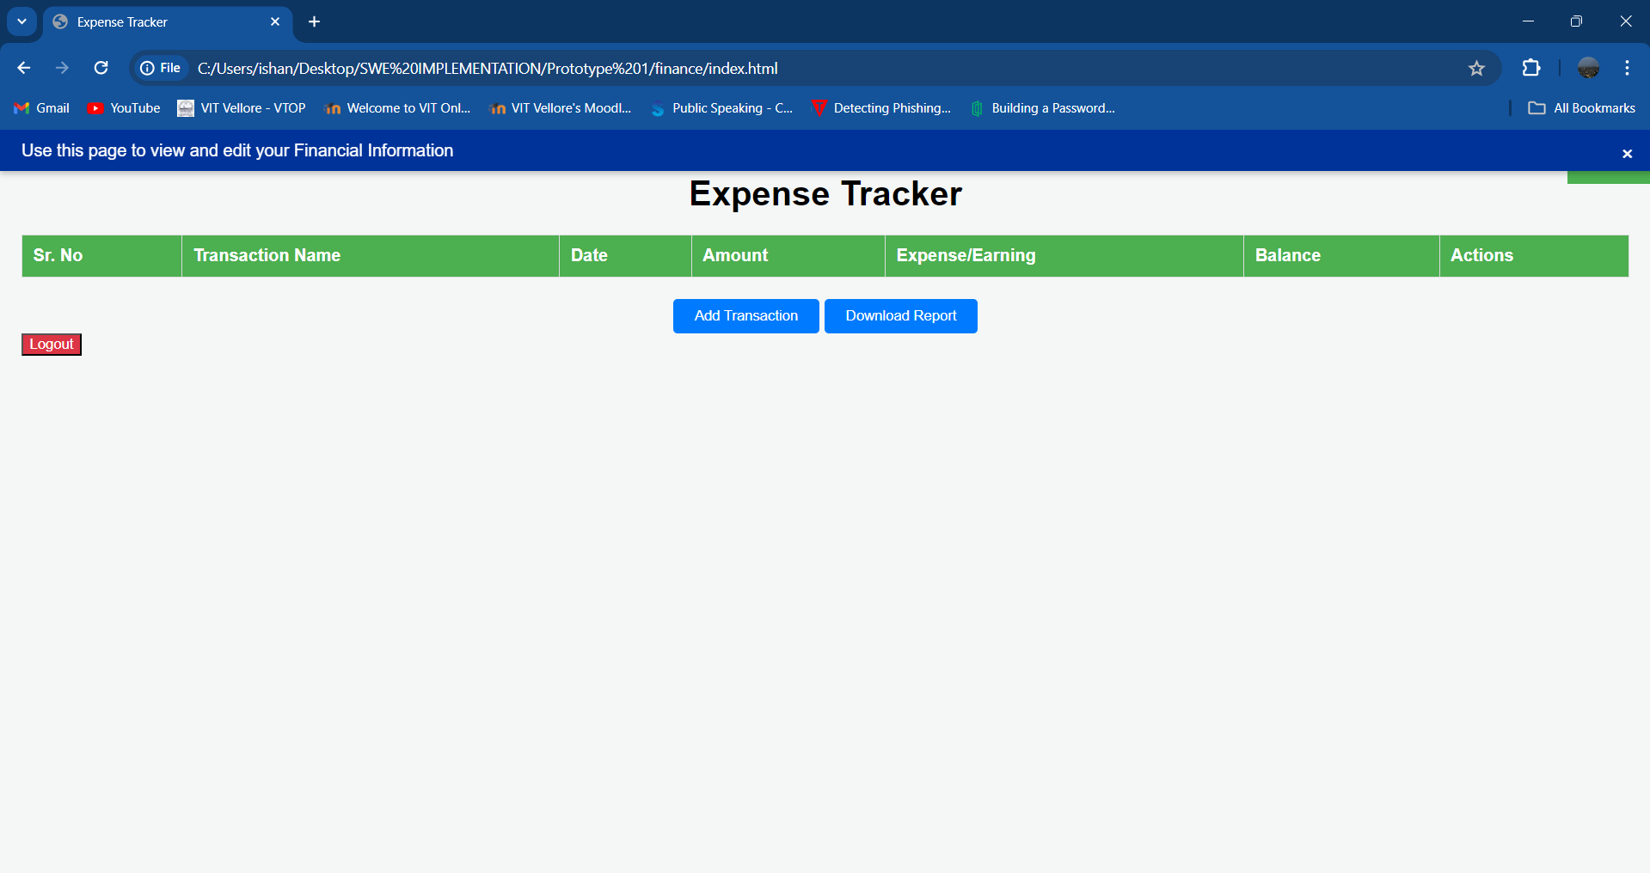

**Rent has been deleted from the table.**

**Test Case – 4: Adding income to the table:**

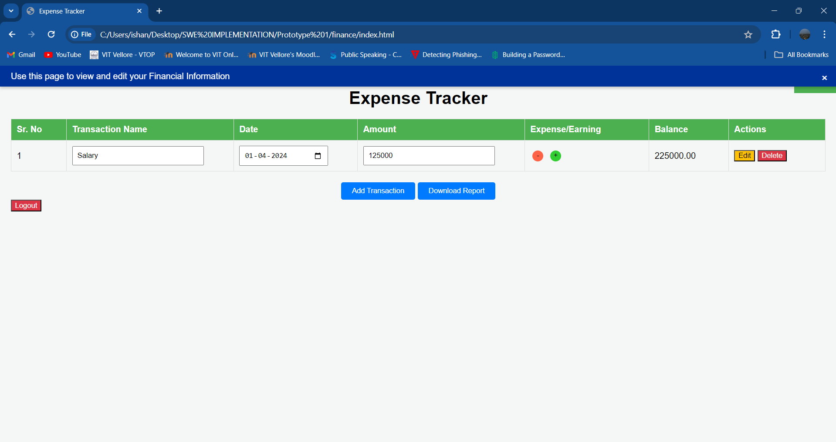

**Salary is counted as income, the green ‘+‘ button is selected.**

**Test Case – 5: Editing income:**

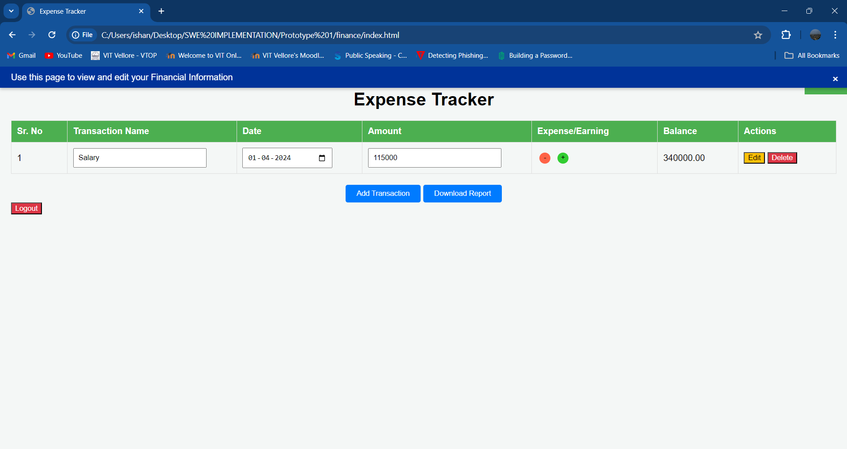

**Salary has been updated to 115000, however, the page has updated the balance to 340000 instead of 215000, as the edit has been applied to the new balance of 225000 and not the old balance of 100000.**

**Test Case – 6: Deleting income:**

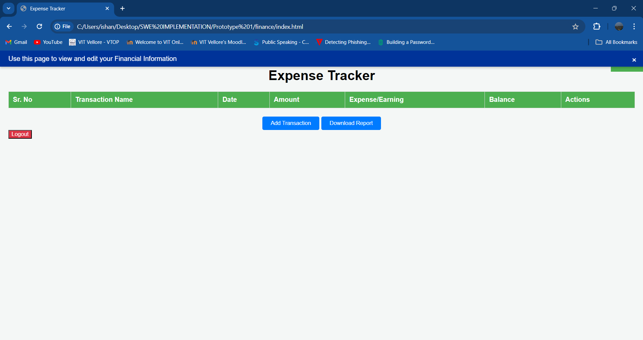

**Salary has been deleted from the table.**

**Test Case – 7: Downloading Expense/Earning Report:**

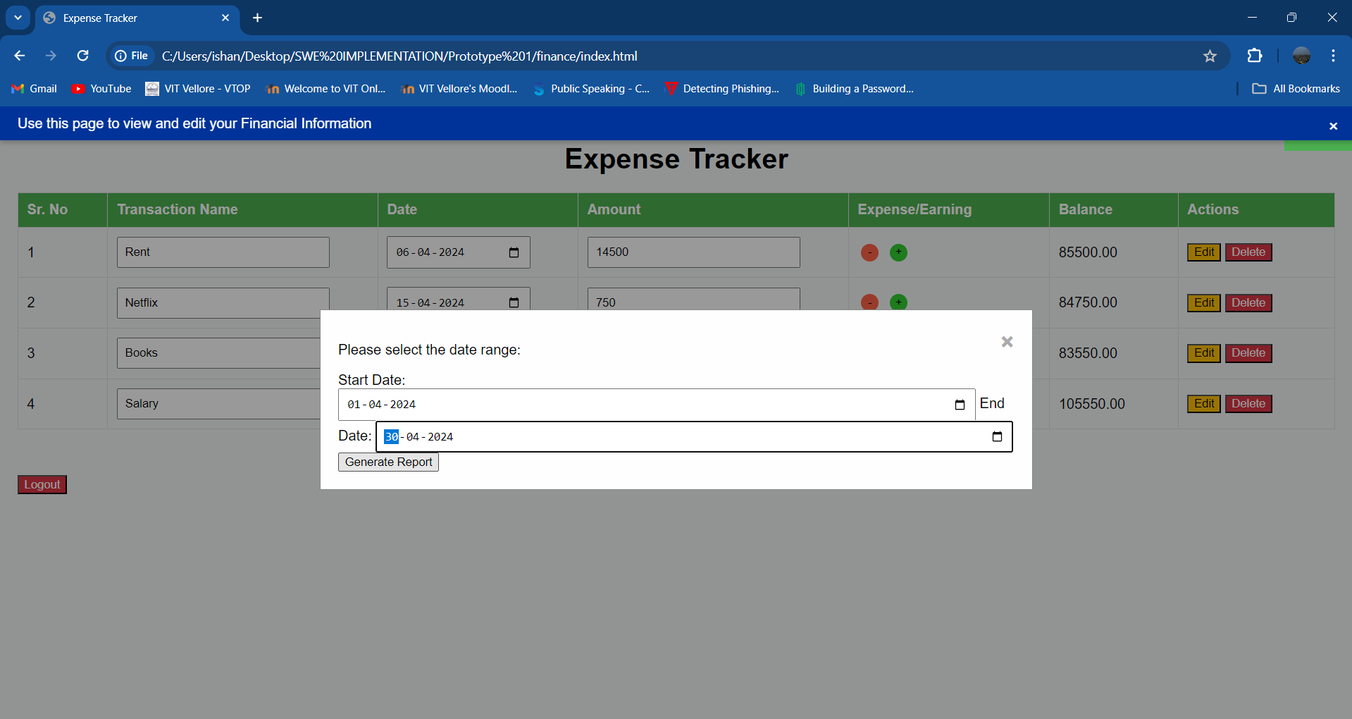

**A date range spanning the entire month of April 2024 has been chosen (01-04-2024 to 30-04-2024).**

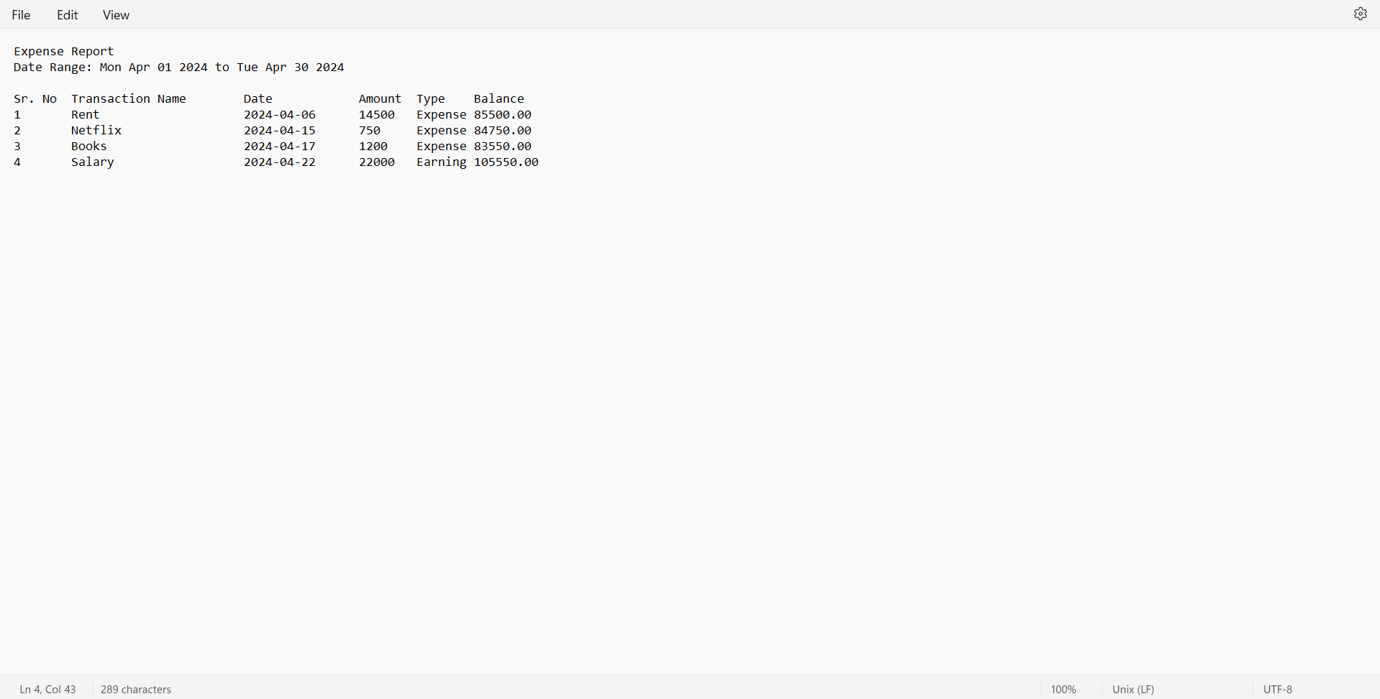

**A report for has been generated for the given date range: (01-04-2024 to 30-04-2024).**

**Test Case – 8: Adding a reminder for a past date:**

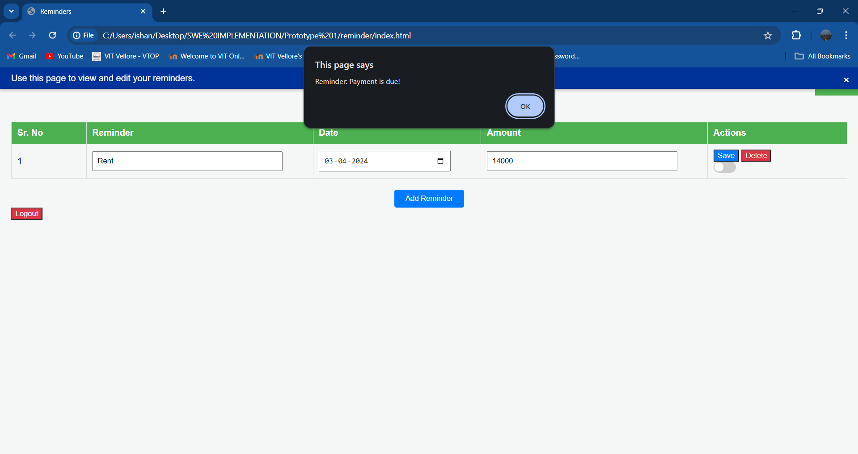

**A reminder has been set for a past date, hence the system prompts the user with an alert.**

**Test Case – 9: Adding a reminder for the current date:**

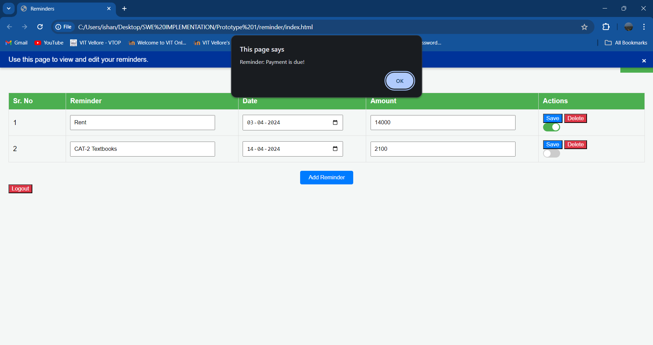

**A reminder has been set for the current date; hence the system prompts the user with an alert.**

**Test Case – 10: Adding a reminder for a future date:**

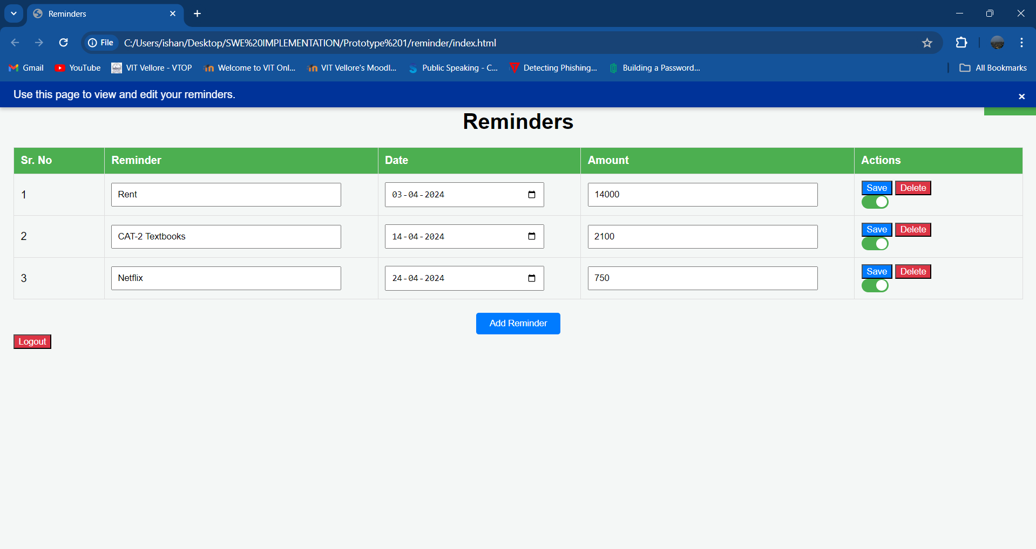

**A reminder has been set for a future date. There is currently no alert.**

**Test Case – 11: Editing a reminder:**

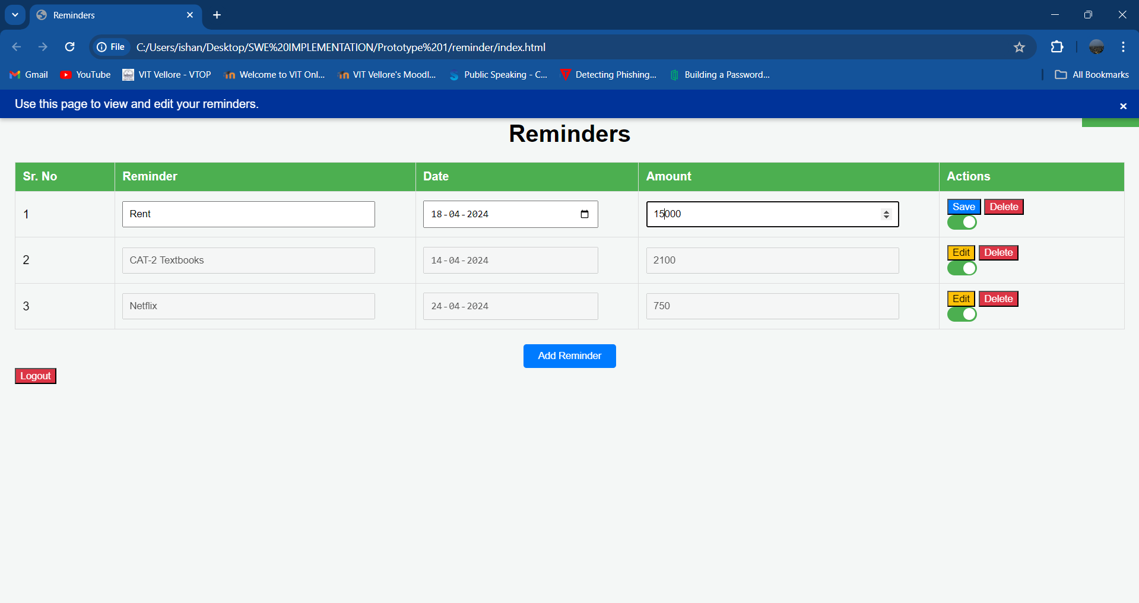

**Rent date has been postponed to 18th April and rent amount has been updated from 14000 to 15000.**

**Test Case – 12: Deleting a reminder:**

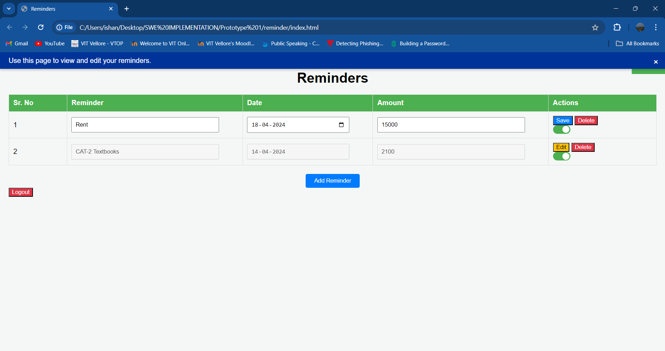

**Reminder for Netflix payment has been deleted.**

**Test Case – 13: Navigating to Finance Page:**

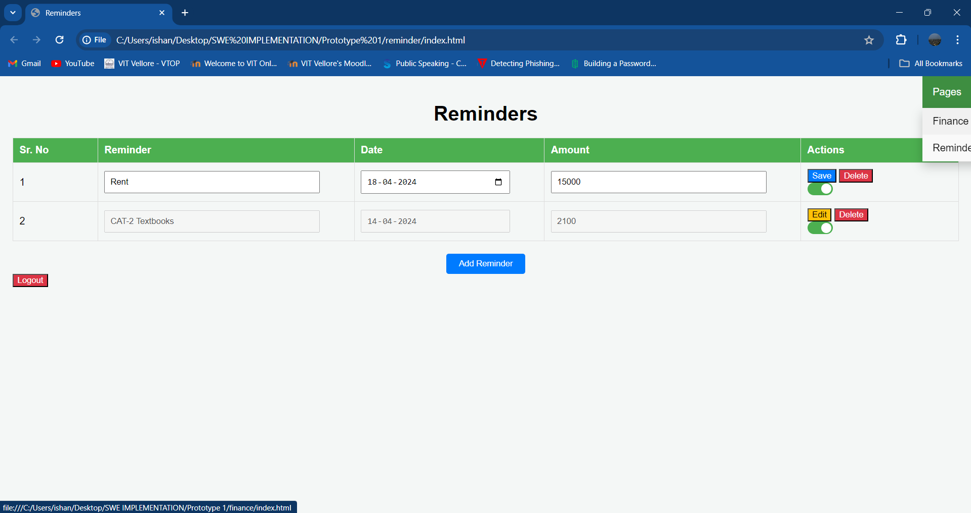

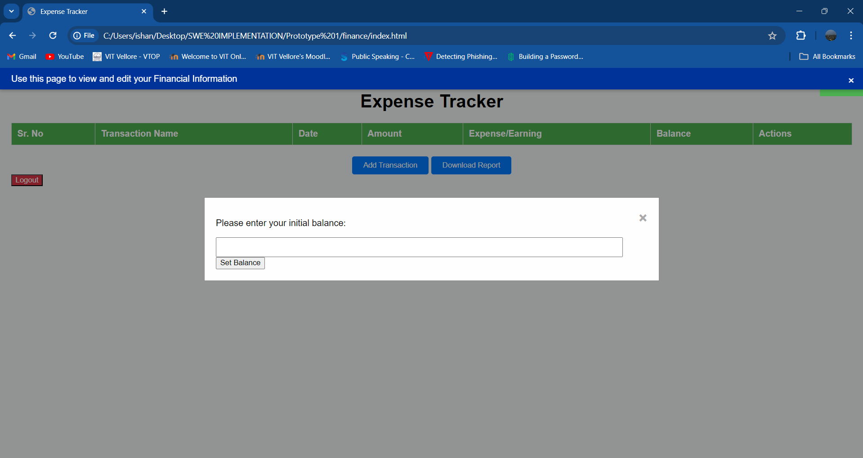

**User navigates from Reminder page to Finance page.**

**Test Case – 14: Navigating to Reminder Page:**

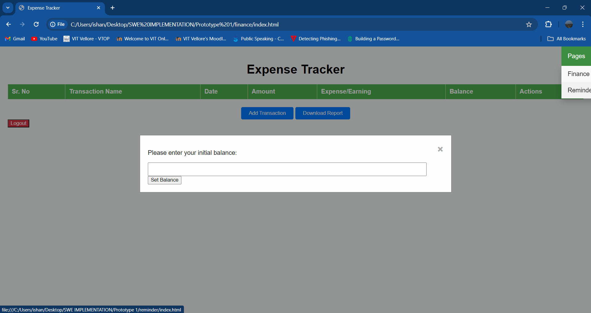

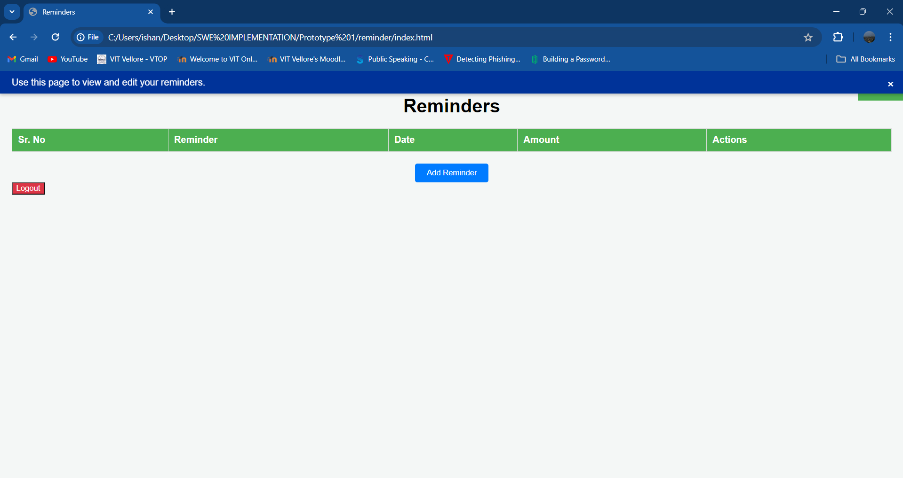

**User navigates from Finance page to Reminder page.**

**Test Case – 15: Logout Button:**

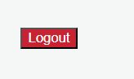

**The logout button closes the application.**